**Request for Proposal 2024:**

**Mobile Telecom Services**

**Appendix: Technical Requirements**

# Technical Specification

## Description of Desired Communication Devices in The company

Blackberry devices (and related items like licences) are currently in the process to be eliminated from the The company mobile fleet. The new operator will need to continue this migration into the new devices approved by the The company policy.

The desired mobile device fleet is:

|  |  |  |  |
| --- | --- | --- | --- |
| **Segment** | **Expected device** | **Number of devices** | **Services associated** |
| High-end | iPhone 15 128Gb | 70 | Voice, e-mail, internet |
| High-end | Samsung S24 256gb | 720 | Voice, e-mail, internet |
| Low to Medium-end |  | 10 | Voice |

Today’s mobile device fleet is described in the appendix.

Tablets devices are out of the scope of this tender (except the related mobile data connections)

Mobile infrastructure (**HQ - Madrid**)

* + Primary Access Description
    - 2 Primary Access located at Madrid | The company Building Mobile - Linked to Gateway and then to the Call Managers (CCMM)
    - 4 Primary Access located at Madrid | The company Building BackUp 5G/4G + Router
    - New operator will propose the dimensión/capacity for those accesses
  + 5G, 3G/4G and 2G coverage in , 48 | The company Building
    - The company building at Madrid is protected from electromagnetic waves transmission and avoid 3G/4G and 2G connection, for this reason it is mandatory to secure internal coverage.
    - 4 antennas by floor (9 floors in Building -> 6 offices floors + Ground Floor + 2 parking floors-located in underground)
    - 2 coverage rings (1 from the parking to 2nd floor and other from 3rd floor to 6th floor)
    - Security
      * Private APN (Access Point Name)
      * Delegated Radius on current supplier
  + Bandwidth – Corporate Madrid: 100 Mbps or upper
  + Internal calls CUG - Closed User Group (From Mobile to Mobile, Mobile to Fixed Line and vice versa)
  + Zero (0) cost between mobile and Headquarters fix numbers

Mobile infrastructure (Telvent – The company IT Supplier)

* + Primary Access Description
    - 1 Primary Access located at Telvent | The company’s supplier Mobile – Linked Gateway and then to the Call Managers (CCMM)
    - 1 EtherChannel Lan_Extension located at Telvent | The company’s supplier
    - New operator will propose the dimensión/capacity for those accesses
  + Bandwidth Telvent: 100Mpbs or upper

See below current infrastructure scheme in Spain (Corporate-Telvent) (where 3G is mentioned, please consider 4G extension and upgrade)

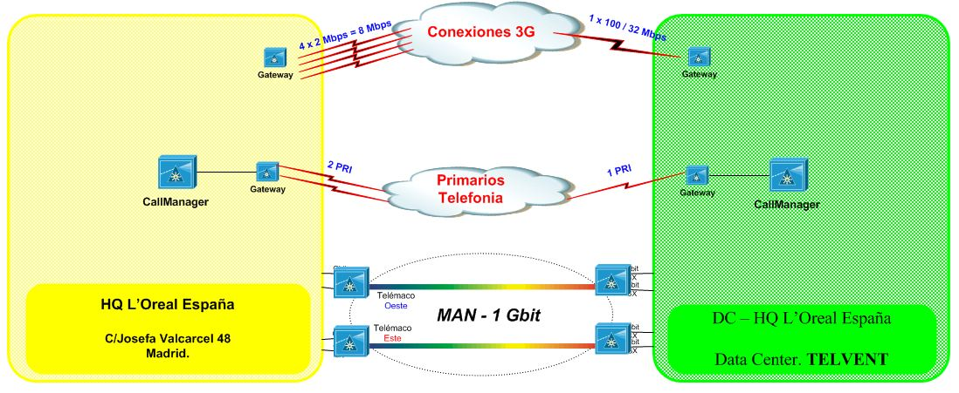

Mobile Infrastucture (**factory**)

* + Primary Access Description
    - Primary Access
    - New operator will propose the new dimensión/capacity for those accesses
  + Security
    - Private APN (Access Point Name)
  + Bandwidth : at least 1000Mpbs + backup
    - Guarantee APN connection and configuration in all locations (Madrid / Burgos)
    - Delegated Radius on supplier

See below devices details:

|  |  |
| --- | --- |
| **Equipamento** | **Total** |
| IPHONE 14 S BLACK 64GB | 335 |
|  | **335** |

See below Sim Cards list:

|  |  |
| --- | --- |
| **Cards** | **Nº** |
| Voice cards | 267 |
| Mobile Internet (national data ilimited) | 3 |
| Mobile Internet (shared) | 276 |
| Others data cards | 19 |
| SMSPRO cards | 5 |